1. Go to SE11
2. Enter the name of DB Table as zXXXXXdbname

Where xxxx is your empcode and dbname is the name of database table.

In this case dept

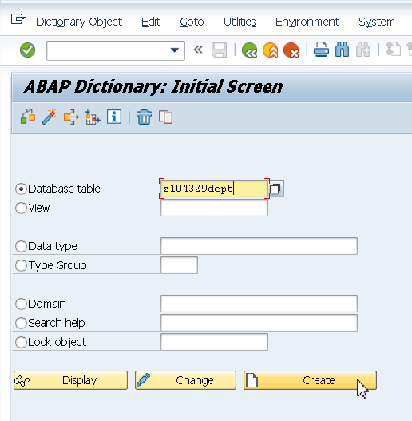

1. Enter Delivery Class and Maintenance status as shown in figure below

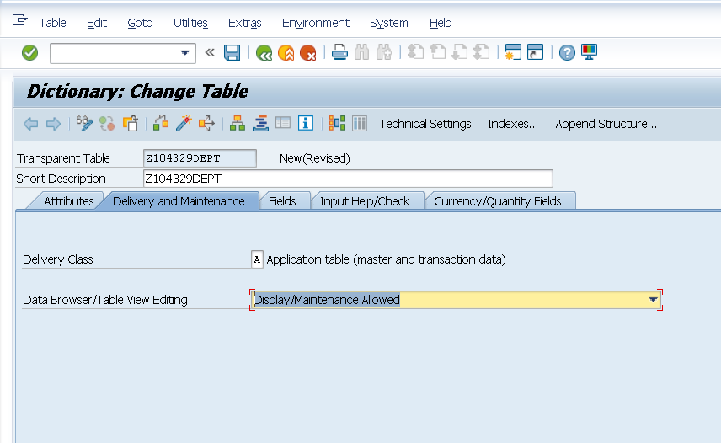

1. Click on Predefined Type.

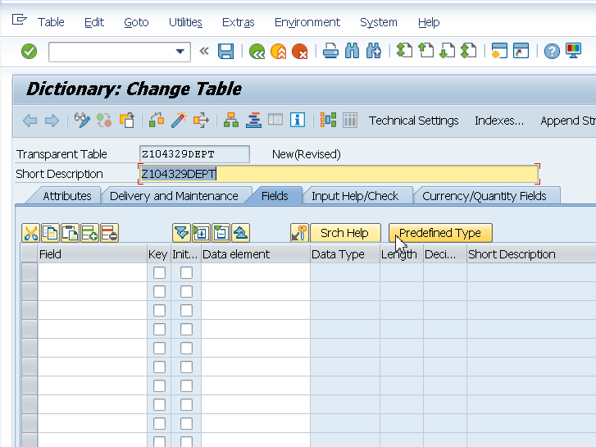

1. Enter fields and Data Type as shown below.

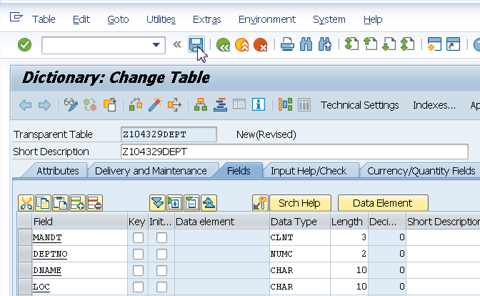

1. Click on Technical settings

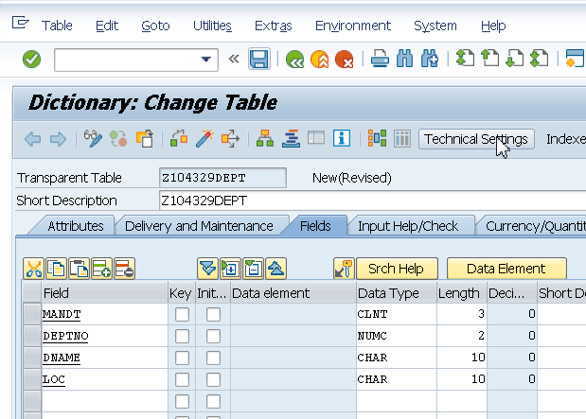

1. Save the table when prompted for.
2. Enter the data class.

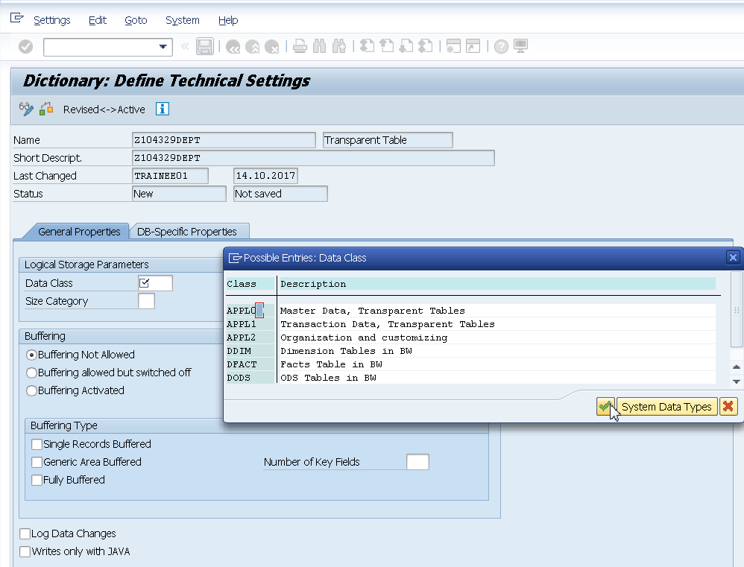

1. Enter the size category.

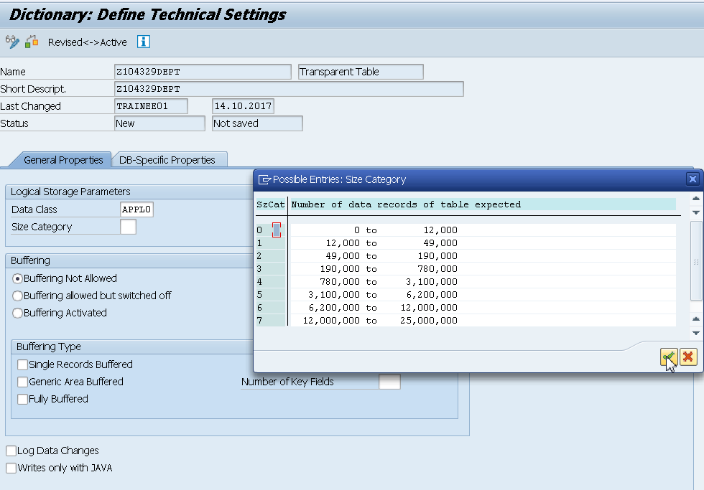

1. Click on back button.

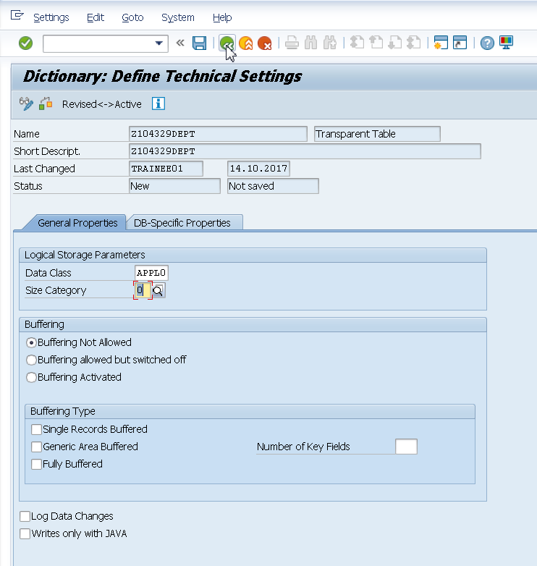

1. Specify the primary keys. Save the table.

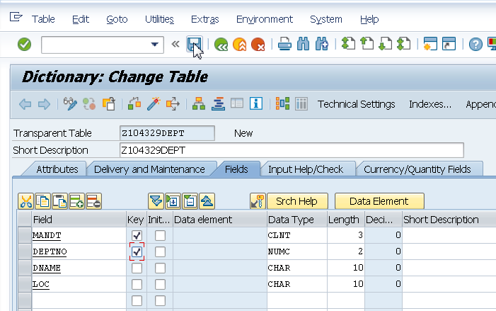

1. Activate the table.